**Class 1:**

**Background of UNIX:**

It was developed in 1969 by a group of AT&T employees at Bell Labs. It originally was an assembly language (An assembly language is a low-level programming language for a computer, microcontroller, or other programmable device, in which each statement corresponds to a single machine code instruction. Each assembly language is specific to a particular computer architecture, in contrast to most high-level programming languages, which are generally portable across multiple systems.). By 1973 is had been almost entirely recoded in C (C is one of the most widely used programming languages of all time and many other languages grew from it including C#, C++, Java, JavaScript, Perl, PHP, etc.).

UNIX is currently owned & managed by [The Open Group](http://www.opengroup.org/unix) – a vendor & technology-neutral industry consortium.

The UNIX operating system is widely used in servers, workstations, and mobile devices.

Good paragraph from Wikipedia: “Unix was designed to be portable, multi-tasking and multi-user in a time-sharing configuration. Unix systems are characterized by various concepts: the use of plain text for storing data; a hierarchical file system; treating devices and certain types of inter-process communication (IPC) as files; and the use of a large number of software tools, small programs that can be strung together through a command line interpreter using pipes, as opposed to using a single monolithic program that includes all of the same functionality. These concepts are collectively known as the Unix philosophy. Kernighan and Rob Pike summarize this in The Unix Programming Environment as "the idea that the power of a system comes more from the relationships among programs than from the programs themselves."”

UNIX-based variants today include Linux, Solaris, HP-UX, AIX, OS X (Apple), iOS (Apple), Android OS, and more.

These variants are called “distributions” because they are custom tailored with certain packages (groups of programs) and can have unique uses. Take a look at the following post from Wikipedia -> <https://en.wikipedia.org/wiki/Linux_distribution> and especially the massive timeline of timeline showing the development of Linux distros as of 2016 -> https://upload.wikimedia.org/wikipedia/commons/1/1b/Linux_Distribution_Timeline.svg

Also take a look at Wikipedia’s Unix history chart to see an evolution of Unix: <https://en.wikipedia.org/wiki/History_of_Unix#/media/File:Unix_history-simple.svg>

History of UNIX on Wikipedia: <https://en.wikipedia.org/wiki/History_of_Unix>

History of Linux on Wikipedia: https://en.wikipedia.org/wiki/History_of_Linux

Some common UNIX-based certifications:

**Linux+** - a good certification that is more general on Linux-based operating systems – it is not vendor specific like Red Hat certs <http://certification.comptia.org/getCertified/certifications/linux.aspx>

**Red Hat Certified Engineer (RHCE)** – this cert is known to be one of the best in the industry

<http://en.wikipedia.org/wiki/Red_Hat_Certified_Engineer#Red_Hat_Certified_Engineer_.28RHCE.29> the exam is focused on Red Hat. There is also Red Hat Certified System Administrator (RHCSA) – this used to be called RHCT (Red Hat Certified Technician) which is entry-level.

**LPIC 1-3**. LPIC 1 focuses on hardware (BIOS, drivers, etc.), LPIC 2 focuses on services (web servers, email, etc.), and LPIC 3 is advanced and considered to be equal to RHCE – students must past LPIC 1 & 2 and the cert also includes the following specialties: Security and High Availability and Virtualization

<http://www.lpi.org/linux-certifications/programs/lpic-1>

**The Linux Foundation certifications** – this is a community that’s gaining popularity and they have two certifications: The Linux Foundation Certified System Administrator (LFCS) and the Linux Foundation Certified Engineer (LFCE).

**Operating Systems**

An operating system would be software such as Microsoft’s Windows or Apple’s Macintosh. Think of it as a set of software, utilities, and drivers that make use of the computer hardware and allows the user to interact with various programs.

Additional resource for your learning: <http://computer.howstuffworks.com/operating-system.htm> - has many pages and a few videos.

**The Kernel**

Under Unix, the operating system consists of many utilities along with the master control program, the kernel. The kernel provides services to start and stop programs, handles the file system and other common "low level" tasks that most programs share, and schedules access to avoid conflicts when programs try to access the same resource or device simultaneously. To mediate such access, the kernel has special rights, reflected in the division between user-space and kernel-space.

**File systems**

In a computer, a file system (sometimes written filesystem) is the way in which files are named and where they are placed logically for storage and retrieval. The DOS, Windows, OS/2, Macintosh, and UNIX-based operating systems all have file systems in which files are placed somewhere in a hierarchical (tree) structure. A file is placed in a directory (folder in Windows) or subdirectory at the desired place in the tree structure.

File systems specify conventions for naming files. These conventions include the maximum number of characters in a name, which characters can be used, and, in some systems, how long the file name suffix can be. A file system also includes a format for specifying the path to a file through the structure of directories.

Examples: FAT (Windows), NTFS (Windows), HFS Plus (Mac OS X), ext* family (Linux), XFS (Linux), ReFS (Windows 8 / server 2012), etc.

**BIOS**

The BIOS is software that is built into the PC and it is the first code run by a PC when powered on (‘boot firmware’).

The BIOS software is built into the PC, and is the first code run by a PC when powered on ('boot firmware'). When the PC starts up, the first job for the BIOS is the power-on self-test, which initializes and identifies system devices such as the CPU, RAM, video display card, keyboard and mouse, hard disk drive, optical disc drive and other hardware. The BIOS then locates boot loader software held on a peripheral device (designated as a 'boot device'), such as a hard disk or a CD/DVD, and loads and executes that software, giving it control of the PC. This process is known as booting, or booting up, which is short for bootstrapping.

BIOS software is stored on a non-volatile ROM chip on the motherboard. It is specifically designed to work with each particular model of computer, interfacing with various devices that make up the complementary chipset of the system. In modern computer systems, the BIOS chip's contents can be rewritten without removing it from the motherboard, allowing BIOS software to be upgraded in place.

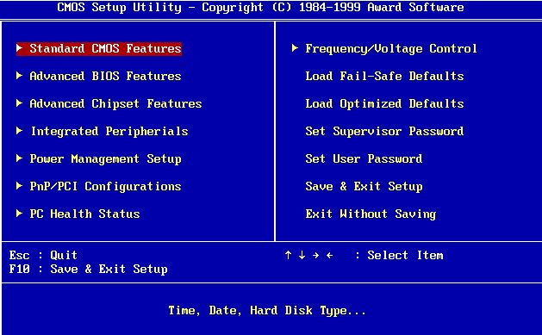

Newer machines now run UEFI:

UEFI (Unified Extensible Firmware Interface) is a standard firmware interface for PCs, designed to replace BIOS (basic input/output system). This standard was created by over 140 technology companies as part of the UEFI consortium, including Microsoft. It's designed to improve software interoperability and address limitations of BIOS. Some advantages of UEFI firmware include:

* Better security by helping to protect the pre-startup—or pre-boot—process against bootkit attacks.
* Faster startup times and resuming from hibernation.
* Support for drives larger than 2.2 terabytes (TB).
* Support for modern, 64-bit firmware device drivers that the system can use to address more than 17.2 billion gigabytes (GB) of memory during startup.
* Capabililty to use BIOS with UEFI hardware.

**Additional Comments:**

Before you are able to install an operating system, you must prepare the hard-drive with the proper formatting or file-system. If a hard-drive is formatted with a FAT file-system, then you won’t be able to install UNIX or Macintosh on it because it is a Windows-based filesystem (in this case you would also only be able to install old versions of Windows that are compatible with FAT).

The term partitioning is also important to know. This is when you “slice” a hard-drive into different parts so that you could install multiple operating systems on it. If you want to run Windows & UNIX at the same time, you would need to partition the hard-drive and allocate space (for example a 100gb hard drive could have 70 gigs for Windows and 30 gigs for UNIX) appropriately for each file-system.

In order to be able to select which Operating System or boot device (hard drive, USB, CD/DVD) to first boot from, you can use the BIOS to select that. In some cases you may also need to use a boot loader (GRUB and LILO are popular UNIX boot loaders). In order to format a drive with specific filesystems or partition a drive, you can use a tool such as Gparted (one of my favorites) – you can make a bootable CD and then you will be able to make partitions using their GUI - <http://gparted.org/livecd.php>

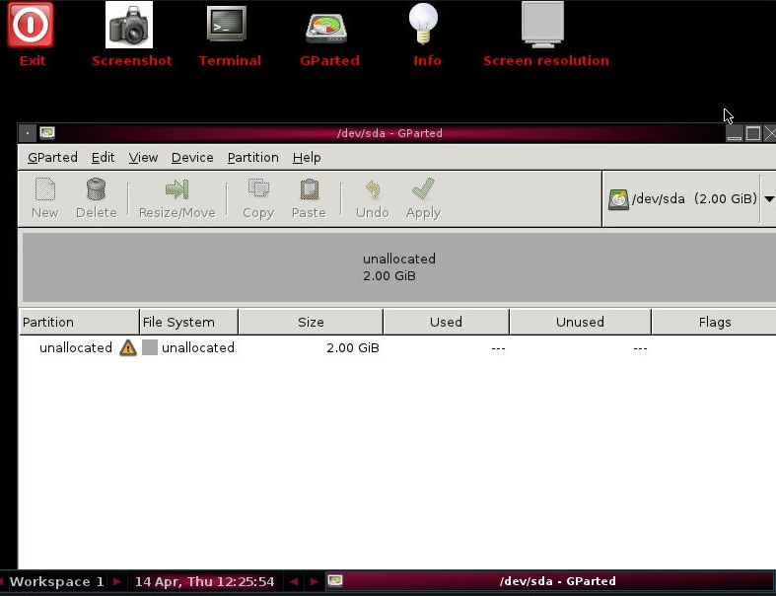

Gparted screenshot.

For your own knowledge, it is important to understand what computer parts make up a PC. You need a CPU, motherboard, RAM, hard-drive, power-supply, and proper cables as a minimum requirement. You can also add external devices (CD/DVD) and video cards for example. This is a good place to start learning about it: <http://computer.howstuffworks.com/>

Links to things that we discussed on a previous class in person:

Good (free) websites for leaning IT-related subjects:

<http://www.danscourses.com/>

<http://www.professormesser.com/>

<http://www.lynda.com/#more_info>

<http://itpro.tv/>

<https://www.udemy.com/>

<https://portal.office.com/start?sku=e82ae690-a2d5-4d76-8d30-7c6e01e6022e> – You can use this to get Office 365 for free as a student (the full-blown Microsoft Office 2016 suite) and you get 5 licenses for your fam.

<http://distrowatch.com/table.php?distribution=centos> – information about the Linux flavor (CentOS) we will use in class. That site has a lot of other distributions (versions of Linux) you can get.

<http://csnw.net/> - A good page for easy access to CS resources from HCC (DreamSpark & Vmware academies, class schedules, open-labs, link to MTA study guides). Note: the schedules only work inside of HCC’s network (very useful to see what courses are offered in different campuses and upcoming semesters).

<https://pcpartpicker.com/> A great place to find computer parts and compare their prices from different vendors

<https://www.gnu.org/software/grub/> - A Linux boot loader

<https://en.wikipedia.org/wiki/LILO_%28boot_loader%29> – A Linux boot loader

<http://www.linuxfoundation.org/> - Good place for free Linux training and they also offer certs.

<https://www.lpi.org/certification/get-certified-lpi/lpic-3-linux-enterprise-professional/> - A strong organization that provides Linux certifications (LPIC 1-3).

<https://www.us-cert.gov/ncas/alerts> - Use this to get the latest security alerts (subscribe with your email)

<https://www.google.com/search?q=computer+goodwill&ie=utf-8&oe=utf-8&aq=t&rls=org.mozilla:en-US:official&client=firefox-a&channel=fflb> – Good place in Houston to find cheap hardware

<http://www.protopage.com> – RSS feed reader / puts feeds in a dashboard – good for aggregating news sources.

<http://www.pearsonitcertification.com/store/comptia-network-plus-n10-006-exam-cram-9780789754103> - Exam Cram series are good for certs

<http://w3techs.com/technologies/overview/web_server/all> - Web server usage stats from w3techs.com

<http://www.opprtunity.com/> - Good place to find sales leads, job opportunities

<http://www.dice.com/> - A good place to find jobs in IT

<http://craigslist.com> – A good place to find jobs, post needs, buy things.

<http://trainingcamp.com> – A good company for training camps to pass certifications

<http://www.etecenter.com/> - A training camp in Houston to pass certifications

<https://www.certificationkits.com/> - A great way to get training for the CCNA & CCNP exams. They have kits including switches, routers, and training material.

<https://www.microsoft.com/learning/en-us/mta-certification.aspx> - - The Microsoft Technology Associate certifications are good for starting out. As an HCC student you are welcome to take any of them (I can proctor the exams) – they’re free! You can only take the same exam once every 24hrs.

<https://wiki.centos.org/Download> - This is the Linux operating system we will be working with in class.

Good companies in Houston to find entry-level jobs (many HCC students & alumni work there or have worked there before):

<http://www.softlayer.com/>

<https://www.alertlogic.com/>

<http://www.hostgator.com/>

<https://cyrusone.com/>

Feel free to share more in the discussion board. Don’t hesitate to ask anything job related / industry related – I may be able to help!